Military Institute of Science and Technology
Department of Computer Science and Engineering
Course Title: Data and Tele-Communication Sessional
Course Code: CSE-318, Cr. Hr: 1.50
Level-3, Term-2

Experiment No: 01

Name of the Experiment: Amplitude Modulation (AM) by Transistor / Balance Modulator

1. Objectives:

  - To understand the basic theory of amplitude modulation (AM).
  - To understand the waveform and frequency spectrum of AM modulator, also calculate the percentage of modulation.
  - To design and implement the AM modulator by using transistor.
  - To understand the measurement and adjustment of AM modulator.
  - To understand the measurement and adjustment of AM modulator.

2. Theory: In amplitude modulation, we utilize the amplitude of audio signal to modulate the amplitude of carrier signal, which means that the amplitude of carrier signal will be varied with amplitude of audio signal. The waveform of AM modulation is shown in figure. 3.1 and its block diagram is shown in fig 3-2. In fig 3-2, we know that in order to generate the AM signal we just need to add a DC signal with the audio signal, and then multiply the added signal with the carrier signal.

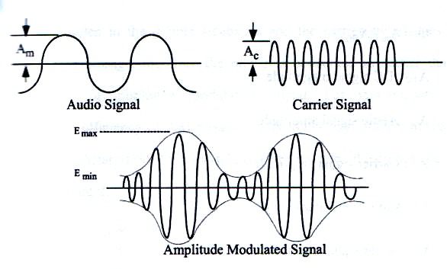

Figure 3-1 Signal waveform of amplitude modulation

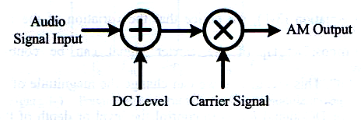

Figure 3-2 Block diagram of AM modulator.

Let the audio signal be 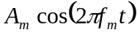 and carrier signal be 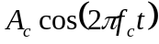 then the amplitude modulation can be expressed as

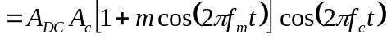 ................................................... 3-1
Where
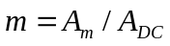.
A_{DC} : DC signal magnitude
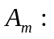Audio signal amplitude.
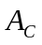: Carrier signal amplitude.
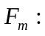Audio signal frequency.
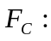 Carrier signal frequency.
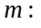Modulation index or Depth of modulation.

From equation 3-1, we notice that the variation of the magnitude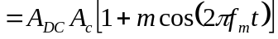 of the carrier signal can be controlled by parameter “m”. This means that we can change the magnitude of the audio signal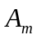 or DC signal 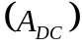 to control the level or depth of the carrier signal. Therefore, parameter “m”is known as the Modulation index.

Besides, we can also rewrite equation (3-1) as

The first term represents double sideband signals; the second term represents carrier signal. From equation (3-2), we can sketch the frequency spectrum of amplitude modulation as shown in figure 3-3. Since the audio signal is hidden in the double sidebands and the carrier signal does not contain any message, therefore the power is consumed in carrier during transmission of amplitude modulation signal. For this reason, the transmission efficiency of AM modulation is lower than double sidebands suppressed carrier (DSB-SC) modulation but its demodulation circuit is much more simple.

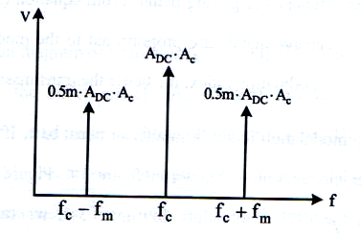

Figure 3-3 Frequency spectrum signal of amplitude modulation signal.

There is an important parameter “m” in equation (3-1) called modulation index or depth of modulation. Normally it is represented in percentage, so we also call modulation percentage. Modulation index is an important parameter in equation (3-1). The definition is as follow

m = 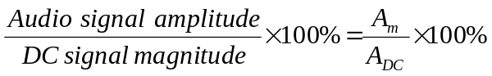 ........................................................... 3-3

Generally, the magnitude of DC signal is not easy to measure; therefore we express the modulation index in another form

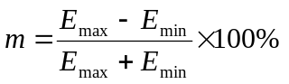 .......................................................................................................... 3-4

Where 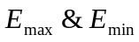 as shown in figure 3-1 are 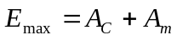 and 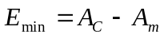
We know that at amplitude modulation, the audio signal is hidden in the double sidebands, so if the double sideband signals are getting stronger, the transmission efficiency is getting better.

From equation (3-2) , we know that the double sideband signals are proportional to the modulation index, Thus the larger the modulation index, the better the transmission efficiency.

Normally modulation index is smaller or equal to 1. If greater than 1, we call it over modulation, as shown in fig 3-4. Fig 3-4 shows the waveforms of the over modulation. In figure 3-4, we can see that the variation of carrier signal is no longer a sinusoidal wave. It is rather a distorted sinusoidal wave, therefore, this kind of AM signal is unable to demodulated and recover to the original by using the envelop detection in next chapter.

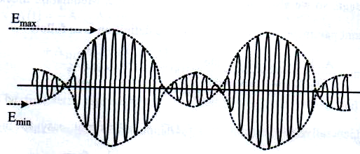

Figure 3-4 Waveforms of the overmodulation

As we know that the AM modulator can be implemented by using a multiplier. However, in electronics circuit, the multiplier is constructed by the nonlinear characteristics of active component. Therefore, in this chapter, we will discuss the design of AM modulator by using a single transistor and balanced modulator.

Transistor AM Modulator
The circuit diagram of transistor AM modulator is shown in fig 3-5. In fig 3-5, the audio signal (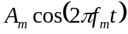) will pass through a transformer and send into the base of the transistor. The carrier signal 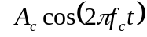 also passes through and transformer and sends into the emitter of the transistor. These two signals will from a small about of small signal voltage difference at the base and emitter of the transistor. The small signal voltage difference is

..................................... 3-5
Then at the collector of the transistor, this voltage difference will produce a small signal collector current as
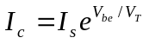 .............................................................................................................................. 3-6
Expand equation (3-6) by Taylor’s expansion, then we get
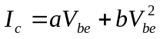 .............................................................................................................. 3-7
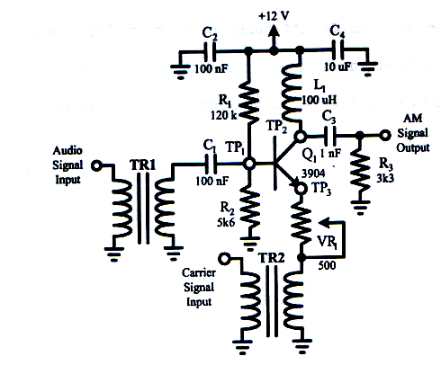

Figure 3-5 Circuit diagram of transistor AM modulator.
In equation (3-7), we notice that after the audio signal and the carrier signal input into the base and collector of the transistor, we can obtain 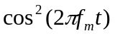, 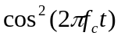 and 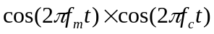Signals at the collector. Then we utilize the filter to obtain the modulated AM signal . In figure 3-5, the inductor L₁, capacitor C_{3,} resister R₃ comprise a high pass filter, which is used to obtain the modulated AM signal. Capacitor C₁ is the coupling capacitor. Capacitor C₂ and C₃ are the bypass capacitors. Resistors R₁ and R₂ are the bias resistors. Variable resistor VR₁ is used to change the operation point of the transistor and it also used to control the magnitude of the carrier, which inputs into the collector of the transistor. Therefore, it can adjust the output signal waveform of the modulator.

3. Equipment Needed

ETEK module of AM modulator
Signal source (Function generator)
Oscilloscope.

- Procedure :

- Refer to the circuit diagram in figure 3-5 or figure ACS3-1 on ETEK ACS 3000-02 module.
- At audio signal input port (Audio I/P), input 1.78V amplitude, 1.235 kHz sine wave frequency; at carrier signal input port (carrier I/P), input 173 mV amplitude, 1294 kHz sine wave frequency.
- Refer to the circuit diagram in figure 3-5 or figure ACS3-1 on ETEK ACS 3000-02 module.
- At audio signal input port (Audio I/P), input 100 mV amplitude, 1 kHz sine wave frequency; at carrier signal input port (carrier I/P), input 300 mV amplitude, 500 kHz sine wave frequency.
- By using oscilloscope, observe of output signal waveforms of AM output port (AM O/P). Adjust VR₁ so that the modulated AM signal is maximum without distortion. Then record the measured results in table 3-2.
- By using oscilloscope, observe of output signal waveforms of the base TP1 and collector TP3 of he transistor. Then record the measured results table 3-2.
- By using oscilloscope, observe on output signal waveforms of the mixing (TP2) of the transistor. Then record the measured results in table 3-2.
- By using spectrum analyzer observe on the frequency spectrum of AM O/P and TP2. Then record the measured results in table 3-2.
- Substitute the measured results into equation (3-4), find the modulation percentage and record in table 3-2.
- According to the input signals in table 3-2, repeat step 4 to 7 and record the measured results in table 3-2.
- According to the input signals in table 3-3, repeat step 2 to 7 and record the measured results in table 3- 3.

Table 3-2 Observe on the variation of amplitude modulation by changing the amplitude of audio signal. (f_{m} = 1KHz, f_{c} = 500 KHz, V_{c} = 300 mV)

Output signal ports | Audio signal amplitudes
Output signal ports | 100 m V | 150 mV
AM O/P
TP1
TP3
TP2
AM O/P
Output signal
spectrums
TP2
Output signal
spectrums
Modulation  Index | E_{max} = _________  E_{min} = _________  m = _________% | E_{max} = _________  E_{min} = _________  m = _________%

Table 3-3 Observe on the variation of amplitude modulation by changing the frequency of audio signal. (V_{m} = 100 mV, f_{c} = 500 KHz, V_{c} = 300 mV)

Output signal ports | Audio signal amplitudes
Output signal ports | 100 Hz | 400 Hz
AM O/P
TP1
TP3
TP2
AM O/P
Output signal
spectrums
TP2
Output signal
spectrums
Modulation  Index | E_{max} = _________  E_{min} = _________  m = _________% | E_{max} = _________  E_{min} = _________  m = _________%

5. Problem discussion

- Explain the objectives of the transistor Q₁ in figure 3-5.
- Explain the objectives of the inductor L₁, Capacitor C₃ and Resistor R₃ in fig 3-5.
- When modulation index, m 50% and 110%, what are the ratio of ?

